Dana Center Higher Education Team
Team Member | Title |  | Contact Info | Photo
Martha Ellis | Interim Director |  | mellis@austin.utexas.edu  512-232-2261 | 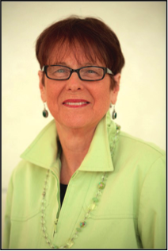
Monette McIver | Manager, Higher Education Services |  | mmciver@austin.utexas.edu  512-475-9737 | 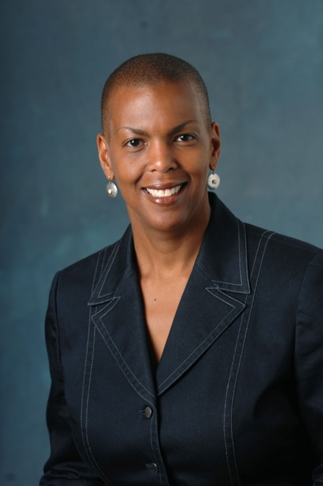
Policy
Carl Krueger | National Policy Specialist |  | ckrueger@austin.utexas.edu  512-232-1437 | 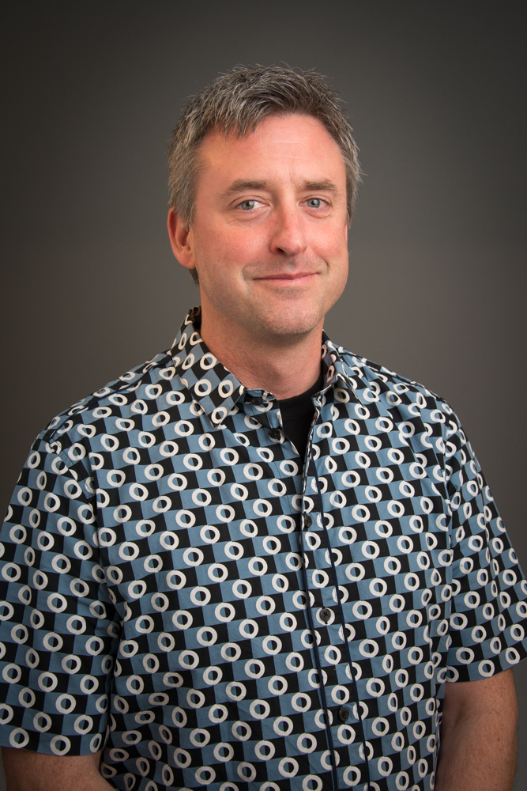
Jeremy Martin | Texas Policy Specialist |  | jeremyryanmartin@austin.utexas.edu  512-232-5806 | 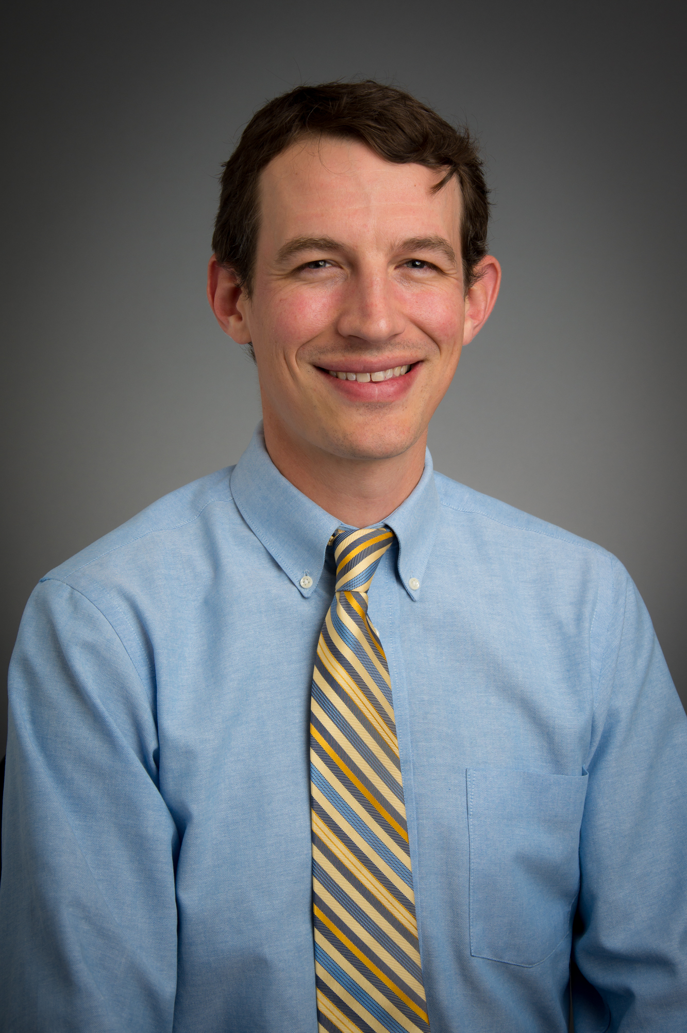
Implementation
Amy Getz | Strategic Implementation Lead |  | getz_a@austin.utexas.edu
Heather Ortiz | State Implementation Specialist |  | heather.ortiz@austin.utexas.edu | 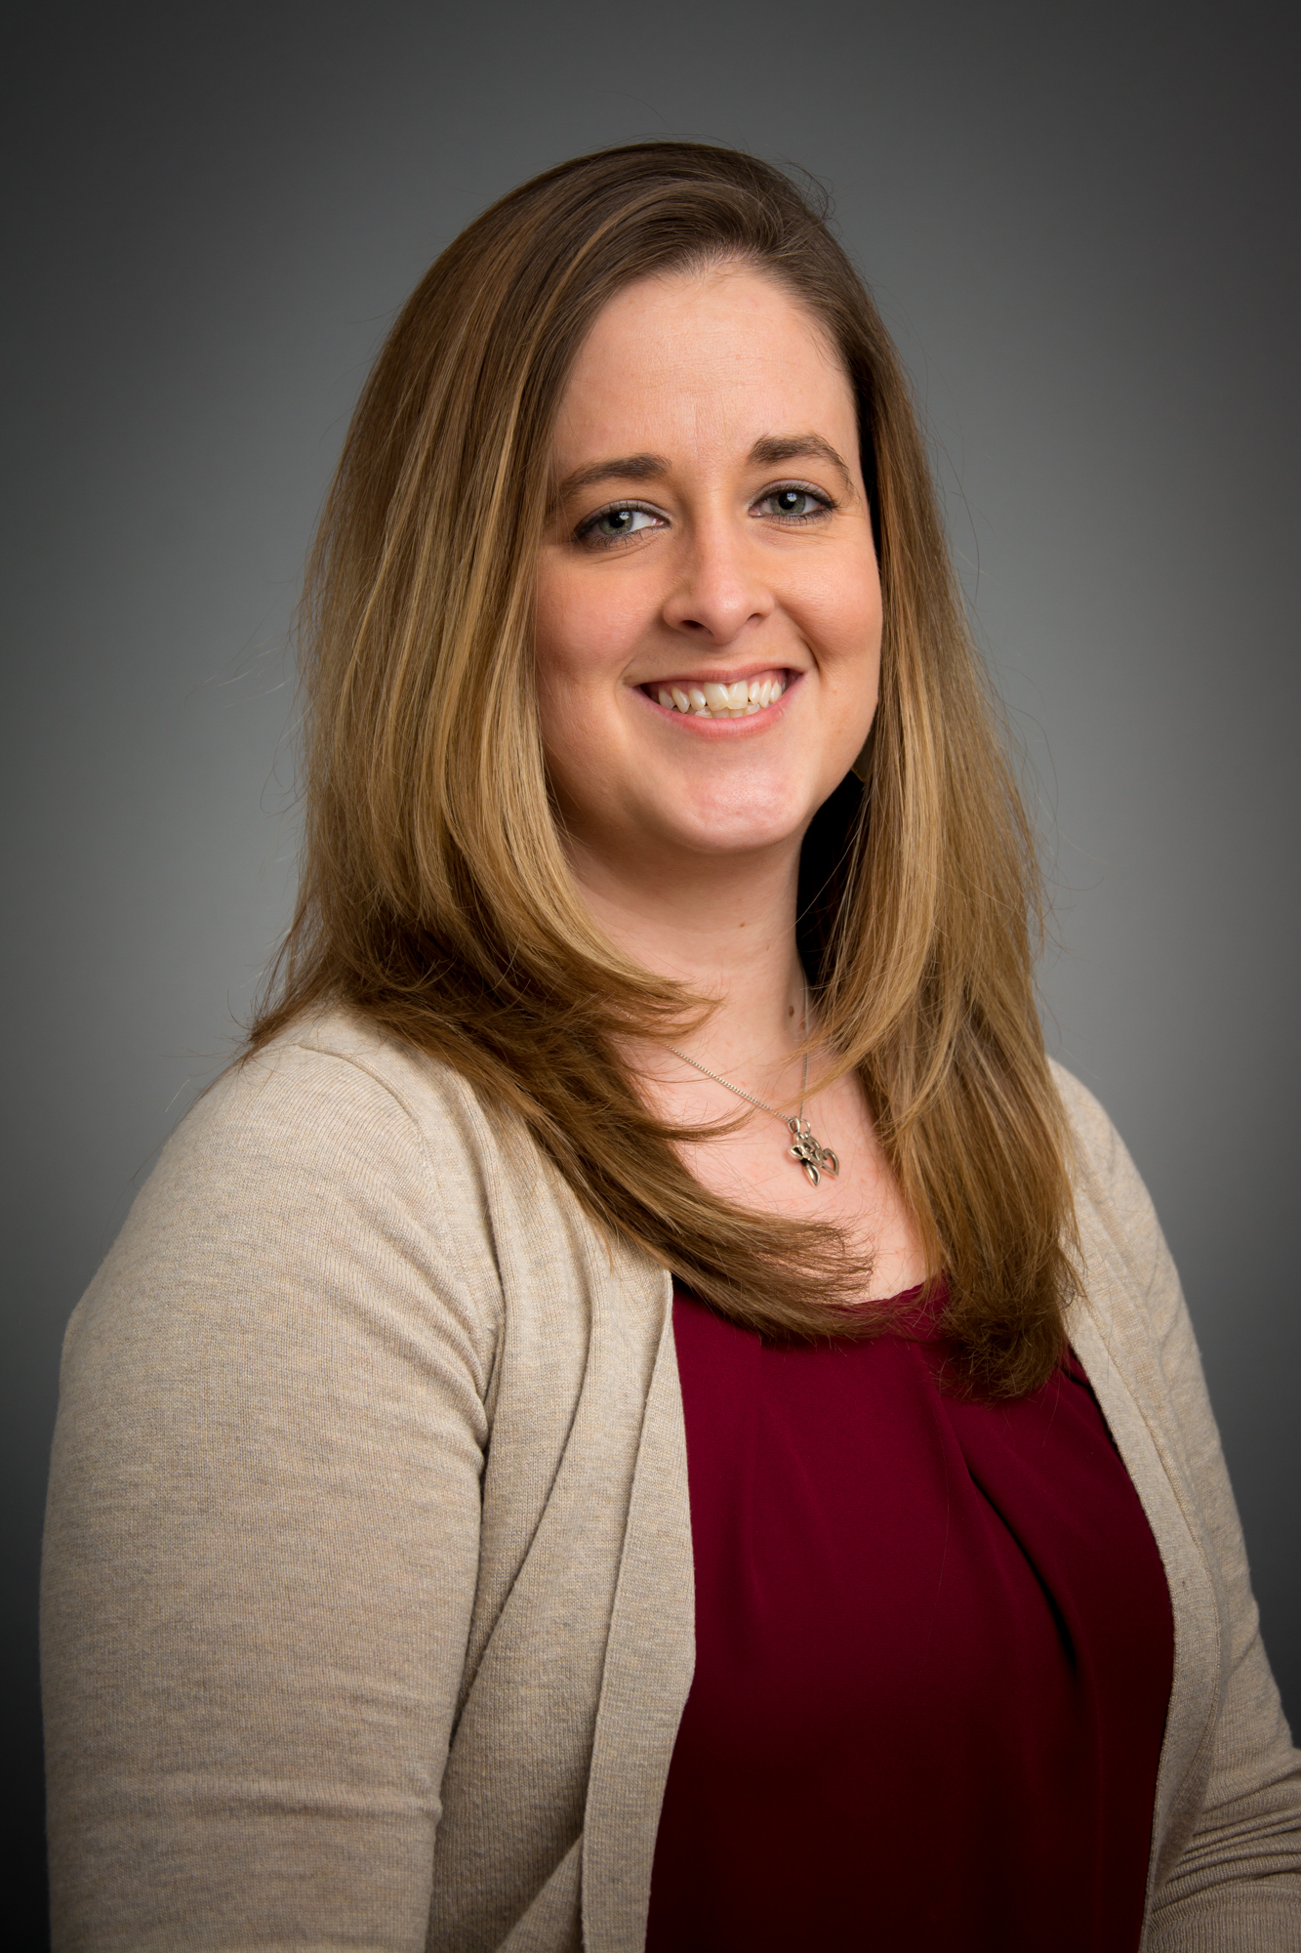
Curriculum Development and Professional Learning
Team Member |  | Title | Contact Info | Photo
Connie Richardson |  | Course Program Specialist  Overall mathematics curriculum, Pearson Lead Liaison, Professional Development Lead | cjrichardson@austin.utexas.edu  512-232-2274 | 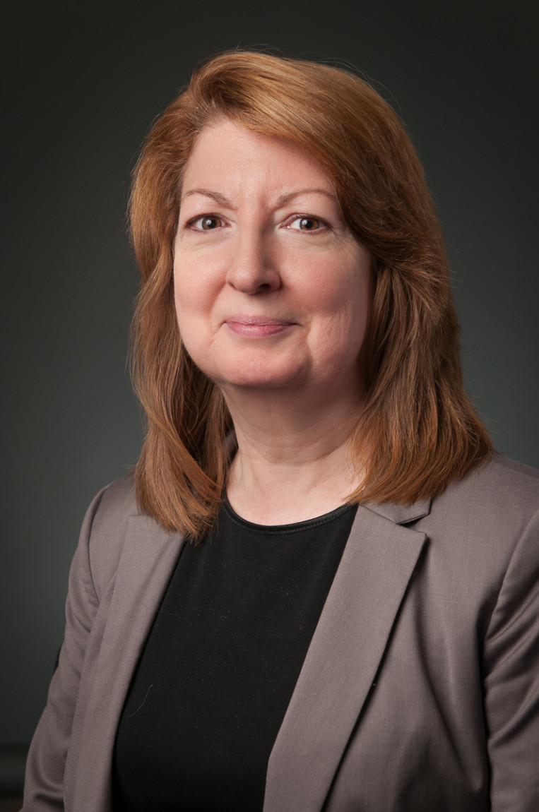
Nancy Stano |  | Research Assistant  Learning Frameworks Course Lead, Professional Learning Team (co-lead for faculty development workshops) | nk.stano@austin.utexas.edu  512-471-5321 | 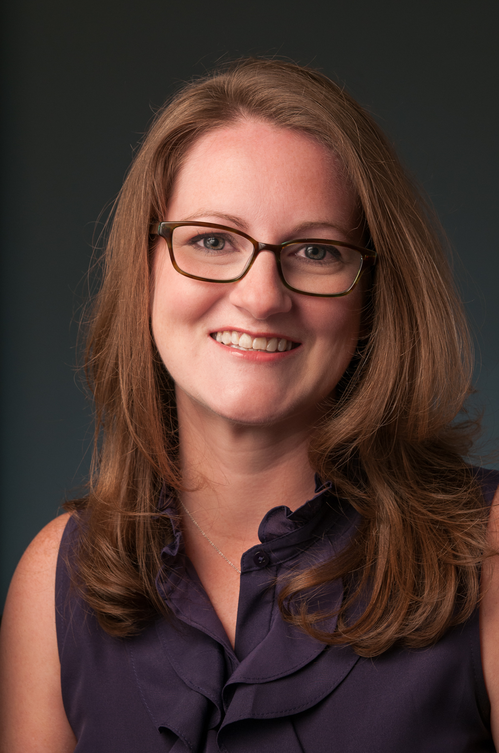
Frank Savina |  | Course Program Specialist  STEM-Prep | fsavina@austin.utexas.edu | 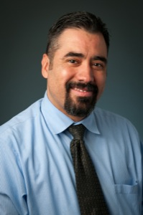
Jeff Shaver |  | Course Program Specialist  SR and FMR v. 3.0 | jmshaver@austin.utexas.edu  512-475-9742 | 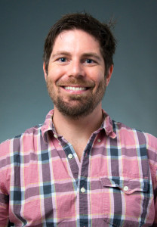
Rebecca Hartzler |  | Strategic Program Development Lead | rebeccahartzler@austin.utexas.edu | 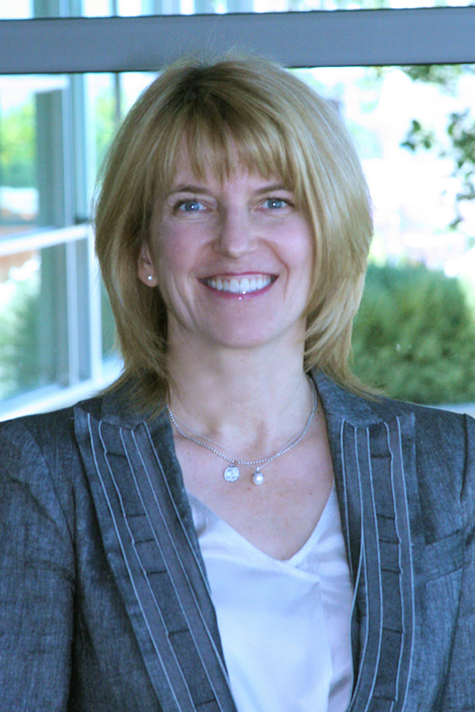
Research & Evaluation
Team Member |  | Title | Contact Info | Photo
Jen Dorsey |  | Senior Evaluation Analyst | dorseyjen@austin.utexas.edu  512-232-4728
K-14 Transition
Lindsay Fitzpatrick |  | Policy Specialist, K-12 Services  College-prep coursework, secondary-to-postsecondary transition | lindsay.fitzpatrick@austin.utexas.edu  512-232-5754
Overall Team Support
Team Member |  | Title | Contact Info | Photo
Erica Moreno |  | Program Coordinator  budgets, whole team logistics | ericamoreno@austin.utexas.edu  512-471-9230 | 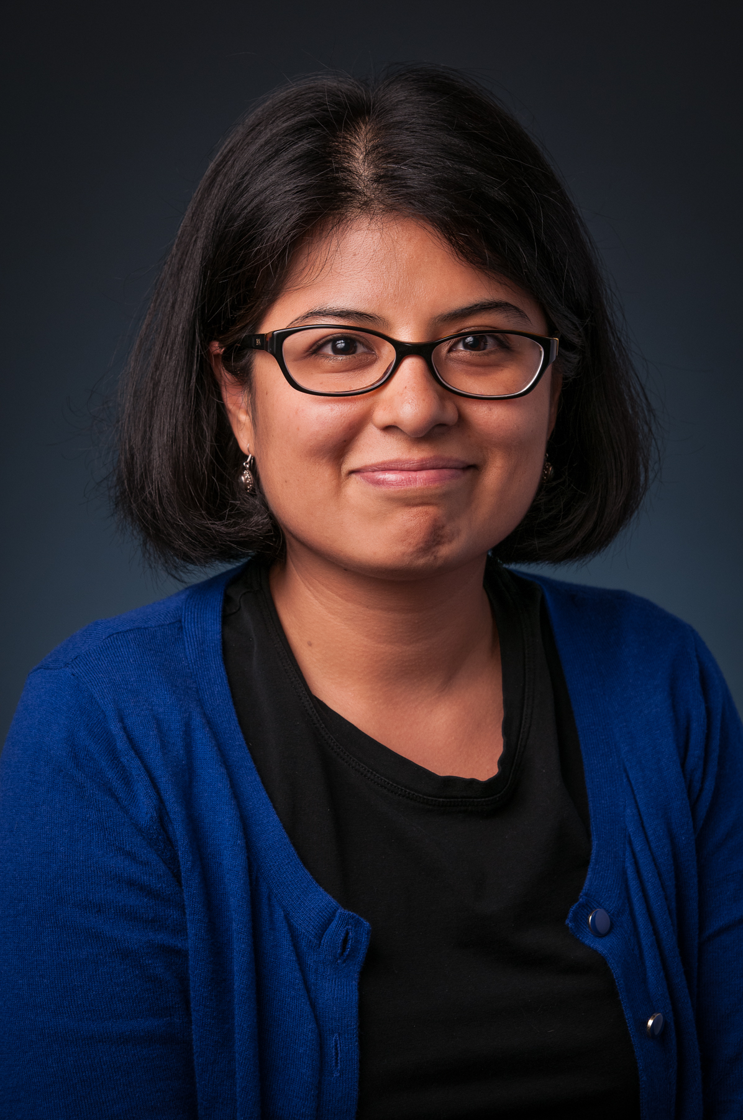
Heather Cook |  | Program Coordinator  summer workshop, event planning | hcook@austin.utexas.edu  512-471-0760
Sarah Wenzel |  | Administrative Associate | sarah.wenzel@austin.utexas.edu  512-471-4242 | 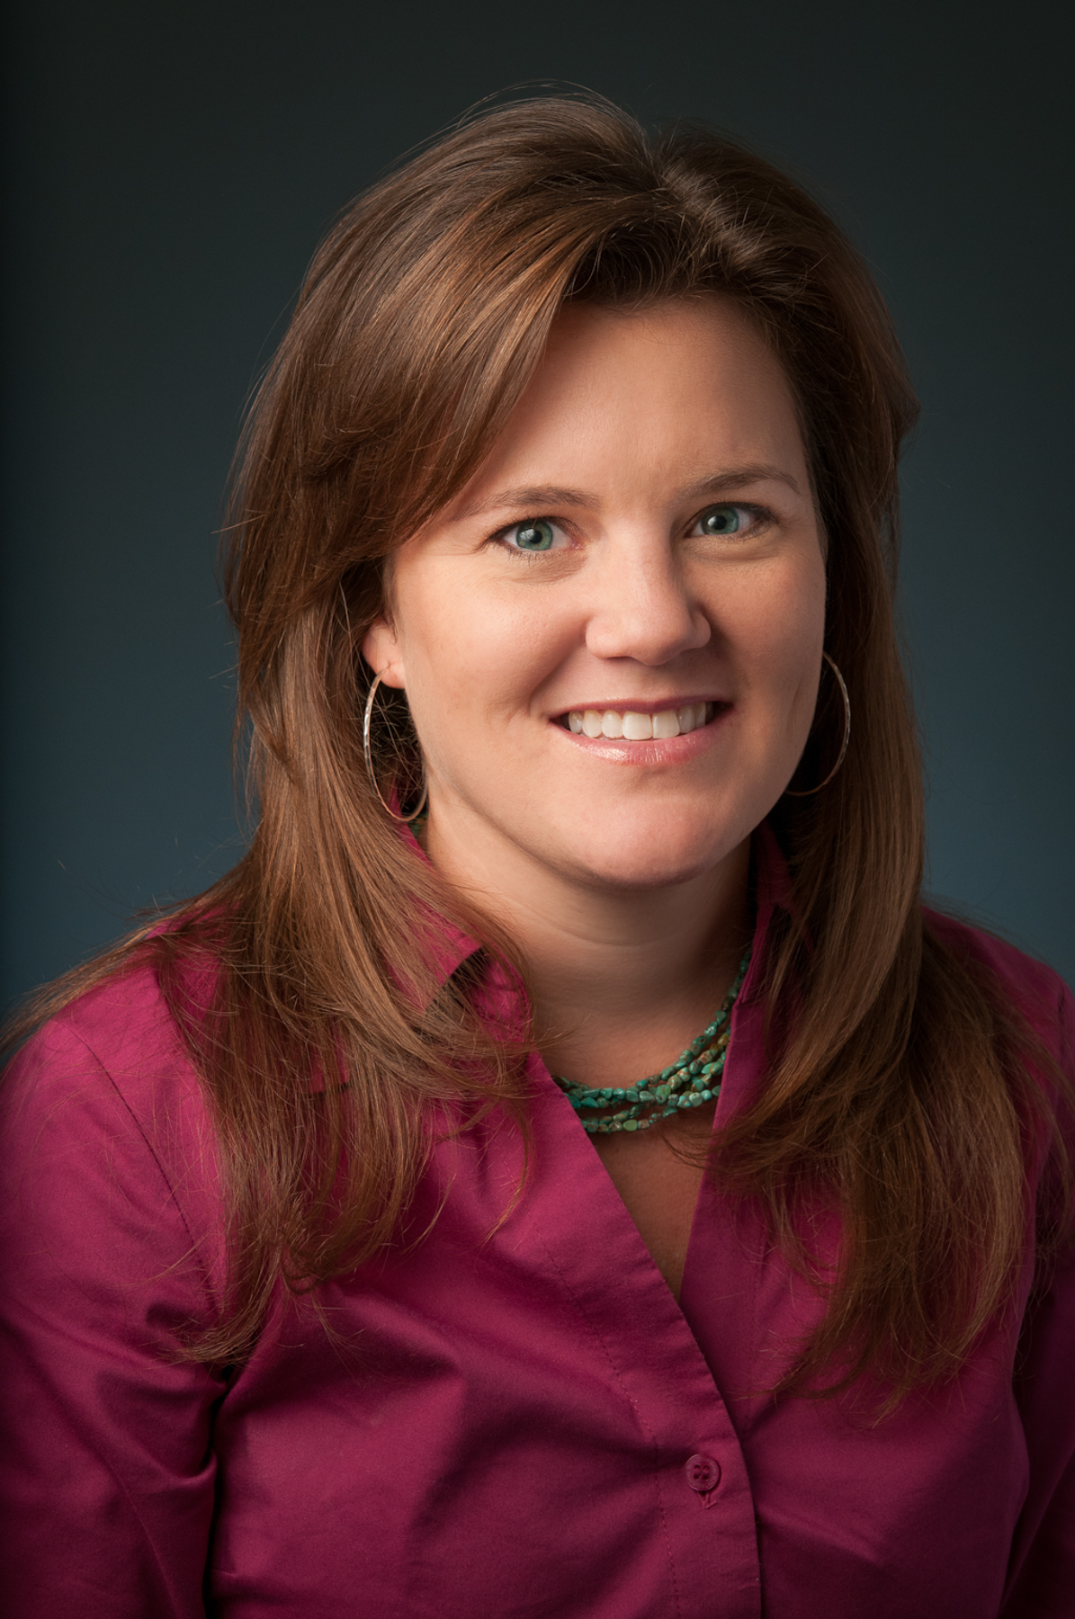
Denise Steusloff |  | (Temp) Event Coordinator | dsteusloff@austin.utexas.edu | Image not available

